Hardworking ond passionate job seeker with strong organizational skills

*eager* to secure entry-levelJob Tille posit on.Ready to help team achieve company goals. To seek and maintain ful time position that

offers professionalchallenges utilizing interpersonal skills,excellent ime management and problem-solving skills.

# Work History

2021-07 -

Current

# Education

2021-06 -

2024-03

2020-06 -

2021-03

2018-06 -

2019-03

## Fresher

Graduate ,*M umbai*

* Skilled at working independently and collaboratively in a **team environment.**
* Proven ability to learn quickly one! oclopt to new

s tuations.

Provided professionalservices ancl support in a clynomic work environment.

lclent fied issues,onolyzecl informat on one! proviclecl solutions to problems.

## Bachelor Of Computer Applications:Bea

*SMT.PN.doshi Women's College* - *Ghatkopor*

## HSC:Science

*SPN.Doshi* Womens *University* - *Ghafkopor*

79 .50

## SSC

*Barvengor School* - *Bhofwodi*

81.60

# Certifications

2023-03

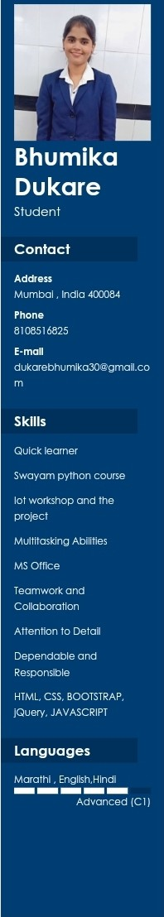

2023-08

2024-05

# Interests

Projects

Swoyom python *tor* elate science course tot workshop

Advance *course*in Web designing {Anuclip foundation) Manual*Software* testing

Web clevetopment, designing Manual*Software* testing

E commerce website of onllne Mobile shop,

II is o website *tor.* viewing mobiles.ode! to cart, viewing description of mobiles and purchasing mobiles online. Tools usecl *are* HTML,CSS,JAVASCRIPT OS front encl ancl

PHP ' MySQL OS OS bockencl.